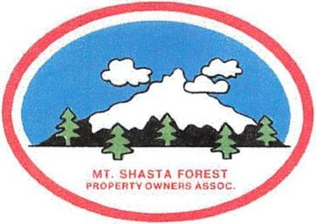
MT SHASTA FOREST POA
ANNUAL JULY EVENTS
2022

Friday, July 22, 2022 – Morning of Golf at the McCloud Golf Course. T-time is at 9:30 am. Please call the Golf Course at (530) 964-2535 to reserve your golf cart and pay your green fees. Reservations are under Barb Lamb – MSFPOA.

Saturday, July 23, 2022 – Annual MSFPOA Picnic at 12:00 pm. We provide BBQ hamburgers, hot dogs, veggie burgers, condiments, water, soda, chips, etc. We do ask our members to bring a side dish of their choice.

Sunday, July 24, 2022 – Beat the heat with a day of Kayaking at the McCloud Reservoir. Meet at the McCloud Reservoir Boat Dock, at 10:00 am. Bring your lunch and drinks.

** RAFFLE DOOR PRIZES DRAWN AT THE PICNIC **

